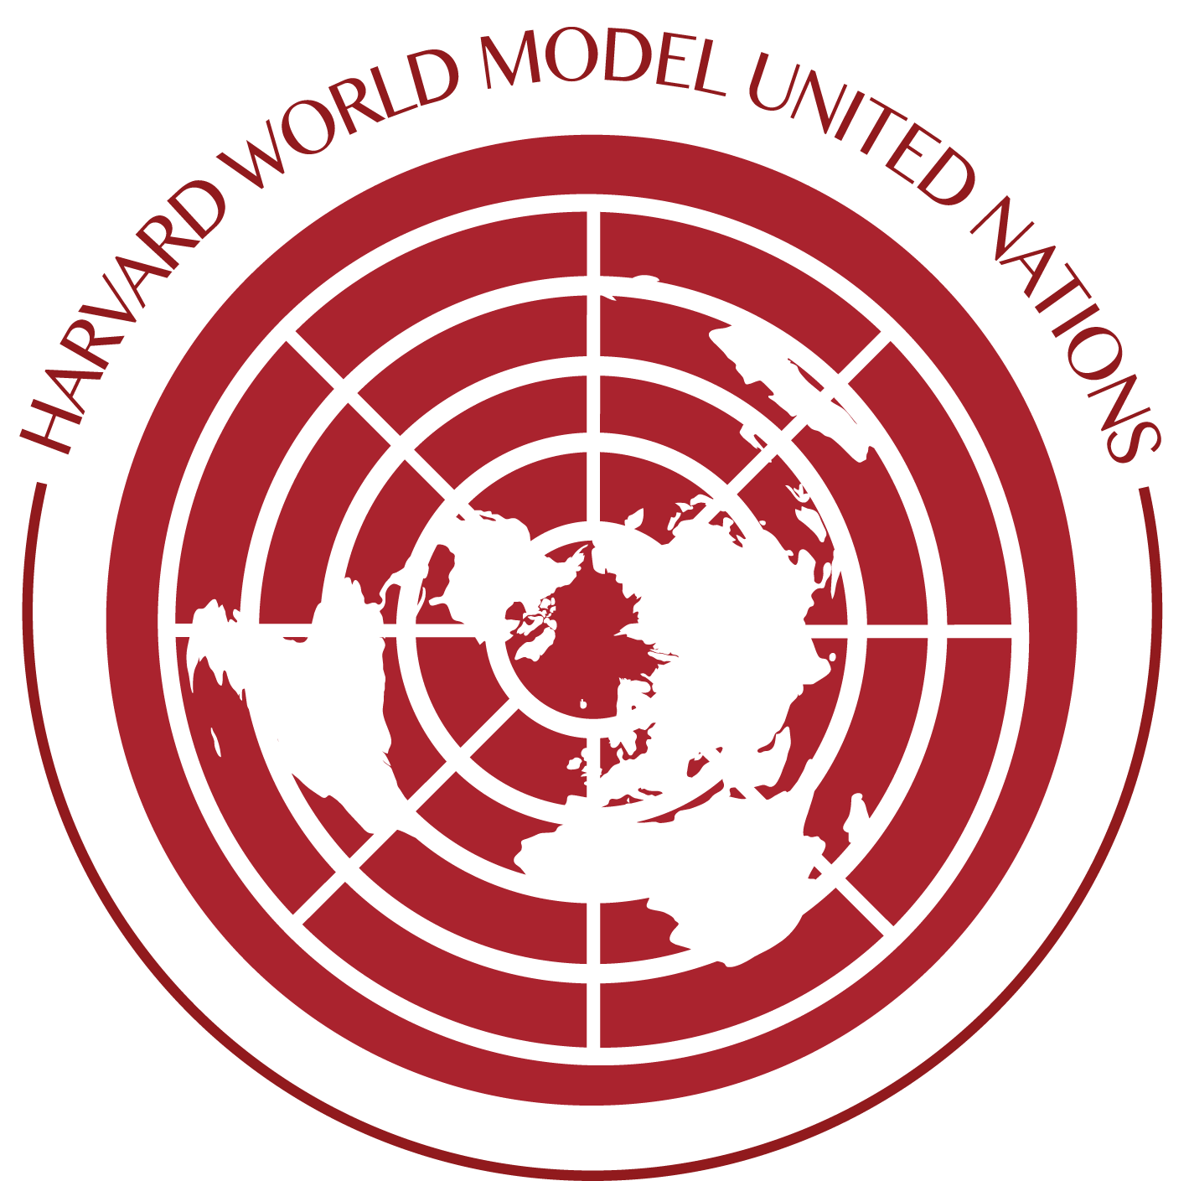
Harvard World Model United Nations 2019
New Chair Application

GUIDELINES:
- This application must not exceed six single-spaced pages, not including the writing sample. Be clear and concise, but make sure you respond to each answer fully.
- You are highly encouraged to speak to Secretariat members and chairs of WorldMUN 2018 in order to get a sense of the expectations of the position. Contact information is provided in the Position Descriptions attachment.
- You must submit your application electronically to applications@worldmun.org by Monday, April 9 at 5:00 PM.
INTERVIEWS:
You will be notified regarding your application status and if you have been granted an interview by Tuesday, April 10, 2018 at 11:59 PM at the latest. Interviews will take place on Tuesday (if possible), Wednesday and Thursday. A more detailed schedule will be announced prior to the interviews.

QUESTIONS:
Please email the Secretary-General, Spencer Ma, should you have any questions regarding the application process at spencerma@college.harvard.edu.

SECTION A: PERSONAL INFORMATION AND PREFERENCES
Name: Year:
E-mail Address:
Concentration:
Phone #: Birthday:
ID# (nine digits): CC #:
House: Room Number:
If your application is not accepted, would you be willing to be on a waitlist?
Yes | No

Please list past experience in Model United Nations (Delegate and/or Staff Experience), Speech & Debate, working with large groups, or other relevant experience in the position you are applying for (No experience is necessary):

SECTION B: Long Answer Section

- What are you most passionate about? Please be as original and specific as possible.

- WorldMUN committees provide interactive simulations of international bodies—from the General Assembly of the UN to the World Health Organization to the European Union—that challenge delegates to work collaboratively on solving today’s most pressing global issues. What are two distinct subjects of international importance that you would want to lead a committee of college-aged students from across the globe in discussing? Please pay attention to the list of topics that have been used in previous WorldMUN’s in order to avoid repetition—WorldMUN champions a variety of committees and topics within the same year and across multiple years as well.

- Write a concise pitch to delegates explaining why they should spend their money and a week of their time addressing one of the topics listed above in a Model UN committee.

- Do you study this issue academically, follow it closely in the news, love talking about it with your friends, aspire to a related profession, or otherwise interact with these topics?

SECTION C: Short Responses

- What are your summer plans? (Please note dates/e-mail accessibility for each activity)

- What are your extracurricular commitments for the upcoming year (2018-2019)? Do you plan to write a thesis/apply to graduate school/participate in on-campus recruiting? If you will be directing or crisis directing for HNMUN and/or HMUN, please note which committee you will be staffing.

- Describe yourself in one paragraph. What drives and motivates your decisions and actions at Harvard?

- How do you see WorldMUN fitting in with the rest of your experience at Harvard?

- Apart from the conference, how do you see yourself contributing to the WorldMUN community over the course of the year?

SECTION D: Writing Sample

Please attach a writing sample to your application email titled “WorldMUN Writing Sample”. This can be writing for any MUN conference you have been a part of in the past or it can be unrelated to MUN. Regardless, it should be at least a 5-7-page academic piece of work that you have already written previously that we will use to assess your writing style.

PLEASE RETURN BY
Monday, April 9, 2018 | 5:00pm
applications@worldmun.org
Please save your document as LastName_FirstName_1stPreference in PDF form.
Please title the email subject line as Last Name, First Name – Chair.

WorldMUN Past Topics

Below is a list of topics that have been used in WorldMUN in the past. This is in no way to discourage you from pursuing a certain topic, since there is always the opportunity to tailor a certain topic to avoid redundancy. If you have any questions about whether or not your topic may be suitable to potentially run at WorldMUN 2019, please do not hesitate to contact us spencerma@college.harvard.edu or manavkhandelwal@college.harvard.edu.

General Assembly
Disarmament and International Security Committee (DISEC)
Biological Warfare (2018)
Women in Armed Conflicts (2017)
Global Mass Surveillance (2017)
Violent Non-State Military Actors (2016)
Occupation of Disputed Territories (2016)

Special Political and Decolonization Committee (SPECPOL)
Uncontacted and Unmarked Cultures (2018)
Arctic Sea Territorial Claims (2017)
Resource Allocation (2017)
State Building (2016)
Skills and Education in Developing Nations (2016)

United Nation’s Children Fund (UNICEF)
Children’s Healthcare Access (2018)

Social, Humanitarian, and Cultural Committee (SOCHUM)
Protecting Religious Freedom for Religious Minorities (2018)
Modern Day Slavery (2017)
Food Security, State Infrastructure and Political Crises (2017)
International Labor Standards (2016)
Police Aggression (2016)

World Health Organization (WHO)
Mental Health Classification (2018)
Reforming the Global Pharmaceutical Industry (2017)
Combating the International Obesity and Diabetes Epidemic (2017)
Water Crisis: Waterborne Diseases and Sustainable Solutions (2016)
Containing Epidemics in the 21st Century (2016)

Economic and Financial Affairs Council (ECOFIN)
Offshore Tax Evasion (2017)
Understanding the Ramifications of Immigrants (2017)
Competitive Currency Devaluation (2016)
Effects of Oil Deflation on Global Markets (2016)

Legal Committee
Intellectual Property Rights and HIV/AIDS Medication (2016)
Cybersecurity (2016)

World Conference on Women (WCW)
Sex Workers and the Commercial Sex Industry (2018)
Women in Corporate/Governance Structures (2016)
Government Institutionalization of Violence Against Women (2016)

United Nations Commission on Trade and Development (UNCTAD)
Technology Gap Between Developing and Developed Countries (2017)
Political Systems and Finance Models of Energy (2017)

Historical General Assembly
Kyoto Protocol (2017)

High Level Political Forum on Sustainable Development Goals
Sustainable Energy (2016)
Sustainable Cities (2016)

ECOSOC&RB
United Nations Development Programme (UNDP)
Economics of Gender Discrimination (2018)

United Nations Human Rights Council (UNHRC)
Securing the Rights of the Rohingya (2018)
Inequality in Education (2017)
Gentrification (2017)
The Right to Health (2016)
Poverty and Inequality (2016)

United Nations High Commissioner for Refugees (UNHCR)
Social and Economic Integration of Protracted Refugee Populations (2018)
Public Health Policy within Refugee Camps (2018)
Current Refugee Crisis (2017)

Committee on Narcotic Drugs (CND)
Heroin Trafficking (2018)
Treatment of Heroin Addiction (2018)

United Nations Educational, Scientific, and Cultural Organisation (UNESCO)
Innovative Education (2018)
Protection of Cultural Heritage (2017)

Committee on Experts of Cybersecurity
Technology in Conflict Situations (2017)

Commission on Science and Technology
Biotechnology for Developing Nations (2016)

North Atlantic Treaty Organization (NATO)
Russia-Ukraine (2017)
ISIS (2017)

African Union
Radical Islam (2017)
Overpopulation (2017)
China in Africa (2016)
Inter-African Network (2016)

Organization of Islamic Cooperation
Stateless Nations and Disputed Territories (2016)
Funding Terrorism (2016)

ASEAN
Trade (2018)
Migrant Workers’ Rights (2018)

Organization of American States (OAS)
Latin American Trade Union (2018)

Committee of Latin American and Caribbean States (CELAC)
Reintegration of Cuba (2017)
Bioethical Dilemmas (2017)
Trafficking in Persons (2016)

European Union (EU)
Preservation of the EU (2018)
Structural Reforms (2016)

Crisis
United Nations Security Council (UNSC)
Cybersecurity (2018)
Burundi (2017)
Boko Haram (2017)
Crisis in Cyprus (2016)

Standing Committee
United Nations Department of Political Affairs’ Mediation Support Unit (2018)
Emergency Summit on European Refugee Crisis (2016)
Global Coalition of HIV/AIDS Pandemic in Botswana (2016)

Continual Crisis Committees
Leaders of la Mesa de la Unidad Democratica, Venezuela 2017 (2018)
Monuments, Fine Arts, and Archives Program (2018)
Suez Crisis, 1956 (2018)
Cabinet of the Republic of Korea, 1976 (2018)
Resolution for Turkey (2017)
Council of Colombian Ministers (2017)
Shah’s Advisers in the Safavid Empire, 1588-1618 (2017)
India-Pakistan Talks, 1987 (2017)
Cabinet of Ministers of the USSR, 1985 (2017)
Mexican Drug Cartel (2017)
FIFA Executive Committee (2016)
Senate of the Roman Republic (2016)
Underground Cabinet of Chinese Ministers (2016)

